**World Quant University**

**Professor: Tiberiu Stoica**

**Econometrics**

Nikolas Lippmann Pareschi - [nikolaslippmann@gmail.com](mailto:nikolaslippmann@gmail.com)

**Mini Project: Banco Central Do Brasil Monetary Policy in a VAR Model**

### Problem1:  VAR Model

1. Discuss the effect of an interest rate shock on the Gross Domestic Product, Consumer Price Index, M2 monetary aggregate and federal funds rate. (Graph 1).

An interest rate shock, as seen below, provoked a linear and large decrease in the GDP. That is expected by economic theory. After that, the effect is the opposite, GDP starts increasing, in a way that resembles a logarithmic curve. It is possible that the interest rate shock was not expected by the market, in other words, the market overreacted to the shock and then just made a small correction. Other hypothesis is that the shock was deluded in time, and the normal Brazilian scenario started to prevail (positive GDP). The picture is below:



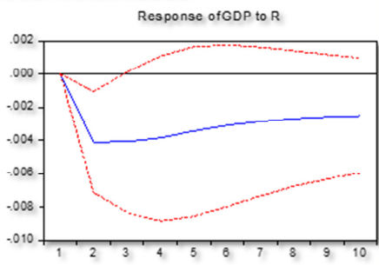

An interest rate shock, as seen below, provoked a decrease in the CPI but with a delay of 2 periods. Some theories suggest that inflation has some inertial (trend) component, which could be an explanation for the lag. The decrease in the CPI deaccelerates with time. The CPI x interest rate puzzle presented in the LAB in WQU classes did not occur in Brazil. Just a delay occurred.



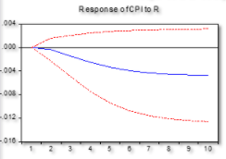

An interest rate shock, as seen below, provoked a decrease in the M2 supply but with a delay of 1 to 2 periods. The curve resembles the previous one, it is possible that CPI and M2 are highly correlated. The decrease in the M2 deaccelerates with time.



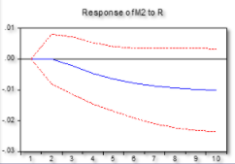

An interest rate shock, as seen below, provoked an increase in the interest rate, suggesting a high autocorrelation, the past explained to some degree the future but the effect was diluted after 7 periods.

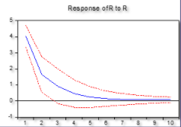

### Problem 2:  Granger Causality

1. What does Granger causality mean? Discuss the Granger causality results.

If there is Granger causality, which is determined by statistical hypothesis testing, one time series is useful in forecasting another time series. The table below reflects the Chi-Square test:

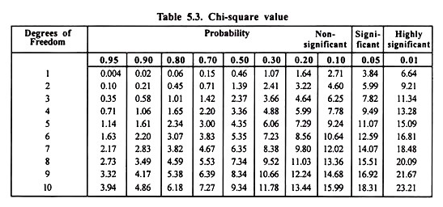

As one can see from the VAR Granger Causality Tests reported below, interest rates predict with significant probability (i.e., the null hypothesis is rejected) GDP, M2 and CPI. The variable which interest rates have more predictive value is M2, with a Chi-Square value of 26.11141, probability of 0.0002 considering 6 degrees of freedom. GDP is also predicted in a high level, with a Chi-Square value of 16.1859, probability of 0.0128 considering 6 degrees of freedom. The dependent variable CPI is predicted still in a significant level, but below the other, with a probability of 0.0409 and a Chi-Square value of 13.13806, considering 6 degrees of freedom. With a Chi-Square value of 11.81144 and a probability of 0.0663 considering 6 degrees of freedom R does not predict R.

### Problem 3:  Cointegration

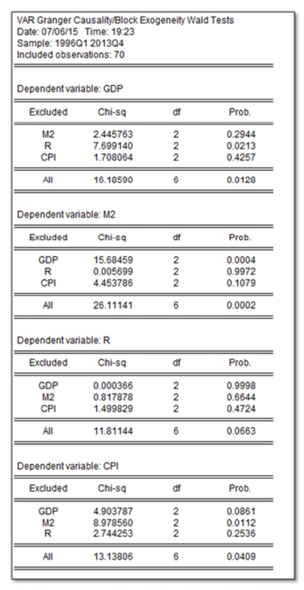

### Problem 3:  Cointegration

What does cointegration mean? Are the variables in the VAR model cointegrated? Should we use a VAR or VEC model for the current analysis? Explain.

If there exists a stationary linear combination of nonstationary random variables, the variables combined are said to be cointegrated. [1]

We reject the hypothesis that there is none cointegrated equations because Trace Statistics = 57.50 and the critical value = 47.85 on the .05 level. We do not reject the existence of at most, 1, 2 or 3 Cointegrated equations.

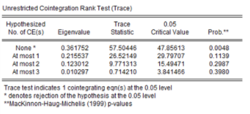

The unrestricted Cointegration rank test also rejects the null hypothesis on the .05 level that none Cointegrated Equations exists. We have a Max-Eigen Statistic of 30.98 and a Critical Value of 27.58. At most 1, 2 and 3 CEs were not rejected:

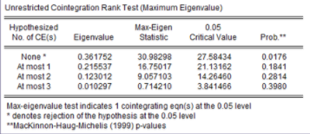

As we have cointegration we should use a VEC model. Also, this makes sense because inflation and interest rates are known to have some trend aspects. In the 80s we had massive inflation in emerging economies and high inflation in developed ones. Interest rates were rising in that decade. Afterwards, in mid 90s to 00 we had a downtrend in inflation rates around the world and in interest rates.

[1] <http://www.eco.uc3m.es/~jgonzalo/teaching/EconometriaII/cointegration.htm>